LIKERT Data Example Solution
The dataset contains 9 likert questions, with questions 4 and 8 negatively worded.
Looking at a LIKERT bar plot (Figure 1), we can see that the questions with the highest percentages of positive response are questions 5 and 1, showing that students were considering campus facilities and resources such as the library and study areas. Of the negatively worded questions, questions 4 and 8 also have a high percentage of disagreeing responses. Question 3 has more than 50% of respondents disagreeing, which illustrates that for many students, disabled facilities were not a key consideration when applying.
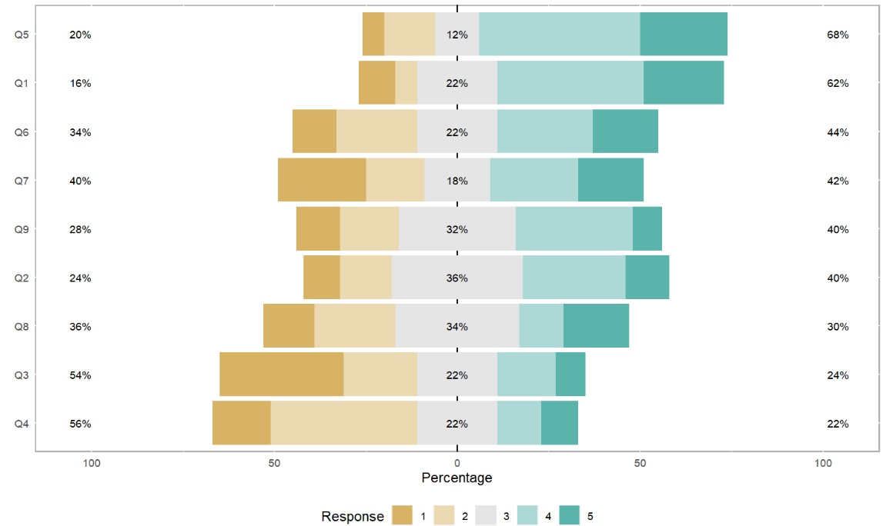
Figure 1: LIKERT bar plots of the nine LIKERT questions.

Considering whether sex or year of study are significantly associated with a higher consideration of campus facilities and resources when applying, it was found that neither had a significant effect (Table 1).
Table 1: Results from logistic regression analyses. A binary variable indicating a high vs low consideration of campus facilities was created and used as the dependent variable.
Variable | OR (95% CI) | P value
Sex | 2.65 (0.81, 8.73) | 0.109
Year of Study | 1.33 (0.62,2.86) | 0.459

Example R Code
campus=read.csv("University Campus.csv")

library(likert)

# Code as factors#

campus$Q1=as.factor(campus$Q1)
campus$Q2=as.factor(campus$Q2)
campus$Q3=as.factor(campus$Q3)
campus$Q4=as.factor(campus$Q4)
campus$Q5=as.factor(campus$Q5)
campus$Q6=as.factor(campus$Q6)
campus$Q7=as.factor(campus$Q7)
campus$Q8=as.factor(campus$Q8)
campus$Q9=as.factor(campus$Q9)

# Create LIKERT Object #

results=likert(campus[,1:9])
likert.histogram.plot(results) # missing data
summary(results, center=3)

plot(results, type="bar")

# Recode as numeric to make summary score

campus$Q1=as.numeric(campus$Q1)
campus$Q2=as.numeric(campus$Q2)
campus$Q3=as.numeric(campus$Q3)
campus$Q4=as.numeric(campus$Q4)
campus$Q5=as.numeric(campus$Q5)
campus$Q6=as.numeric(campus$Q6)
campus$Q7=as.numeric(campus$Q7)
campus$Q8=as.numeric(campus$Q8)
campus$Q9=as.numeric(campus$Q9)

campus$Q4=6-campus$Q4
campus$Q8=6-campus$Q8

# Create summary score and binary DV

campus$summary=rowSums(campus[ , c(1:9)], na.rm=TRUE)
campus$high <- ifelse(campus$summary>=31.5, "high", "low")
campus$high=as.factor(campus$high)
relevel(campus$high,2)

# Convert factors

campus$Gender=as.factor(campus$Gender)

# Create model

model=glm(high~Year.of.Study+Gender, family="binomial"(link="logit"), data=campus)

summary(model)
exp(model$coefficients)

confint=confint.default(model)
exp(confint)

